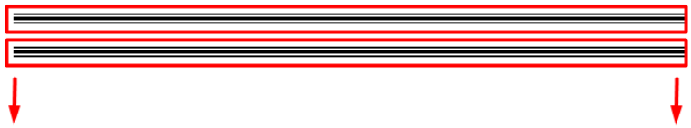تمام تعالى بقا نركب ال plugin الجميله ده دى الى انا اختارته تكون ال sidbarالحصرى للموقع

<https://www.jqueryscript.net/menu/Multi-Level-Sidebar-Menu-HC-MobileNav.html>

<https://www.jqueryscript.net/demo/Multi-Level-Sidebar-Menu-HC-MobileNav/>

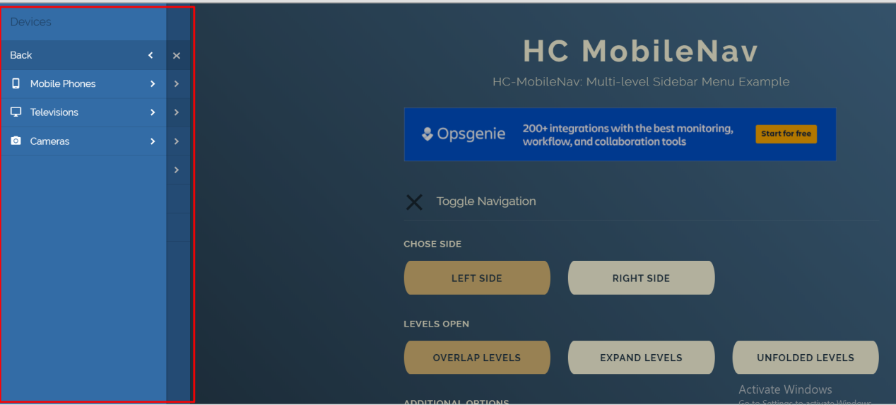

اهى هنشوفها دلوقت اى النظم وطريقه تركيبها

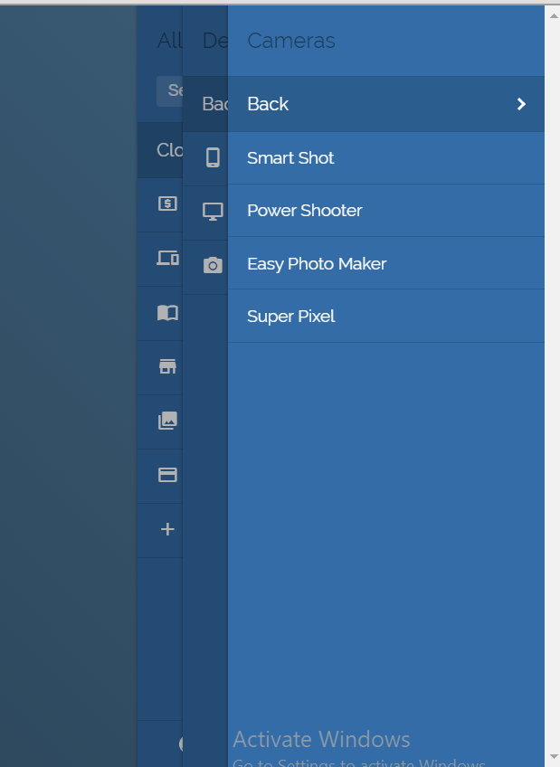

تمام الموضوع كله فى ال 3 ملفات دول مش اكثر ولا اقل

تمام الحمد لله بفضل من الله ركبنها بى شكل احترفى وكويس جدااااااااااااا كمان

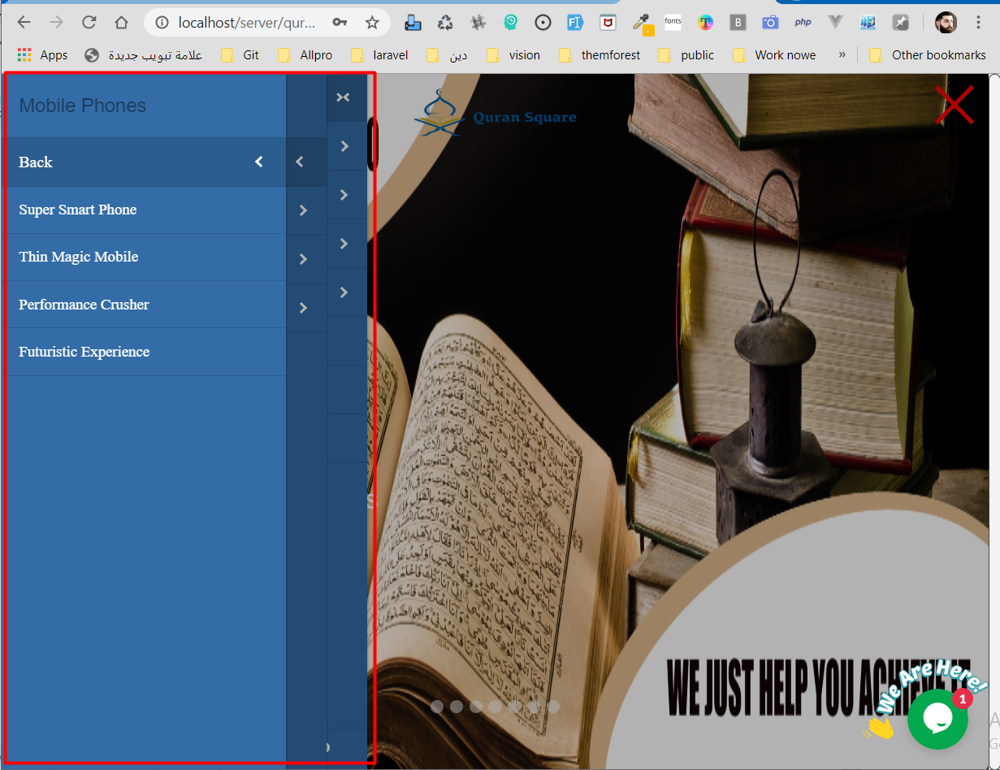

كل الموضوع بس كان محتاج شويه تنسيق css وكده

ده ال html بتعها

<!--====== start Slider show in mobile=============================== -->  
<section class="content_sidbar">  
 <div class="md_show d-none" id="container33">  
  
 <aside></aside>>  
  
 <div class="wrapper cf">  
  
 <nav id="main-nav">  
  
 <ul class="first-nav">  
 <li class="search d-none">  
 <div class="form-container">  
 <form class="search-form" action="https://www.google.com/search" target="_blank" method="get">  
 <input type="text" name="q" placeholder="Search..." autocomplete="off">  
 </form>  
 </div>  
 </li>  
 <br>  
 <br>  
 <br>  
 <li class="cryptocurrency">  
 <a href="https://www.google.com/search?q=Crypto" target="_blank">Cryptocurrency</a>  
 <ul>  
 <li><a href="#">Bitcoin</a></li>  
 <li><a href="#">Ethereum</a></li>  
 <li class="add"><a href="#" data-nav-close="false" data-add="['Litecoin','Dogecoin','Bitcoin Cash','ZCash']">Add Coin</a></li>  
 </ul>  
 </li>  
 </ul>  
  
 <ul class="second-nav">  
 <li class="devices">  
 <span>Devices</span>  
 <ul>  
 <li class="mobile">  
 <a href="#">Mobile Phones</a>  
 <ul>  
 <li><a href="#">Super Smart Phone</a></li>  
 <li><a href="#">Thin Magic Mobile</a></li>  
 <li><a href="#">Performance Crusher</a></li>  
 <li><a href="#">Futuristic Experience</a></li>  
 </ul>  
 </li>  
 <li class="television">  
 <a href="#">Televisions</a>  
 <div class="subnav-container">  
 <ul>  
 <li><a href="#">Flat Superscreen</a></li>  
 <li><a href="#">Gigantic LED</a></li>  
 <li><a href="#">Power Eater</a></li>  
 <li><a href="#">3D Experience</a></li>  
 <li><a href="#">Classic Comfort</a></li>  
 </ul>  
 </div>  
 </li>  
 <li class="camera">  
 <a href="#">Cameras</a>  
 <ul>  
 <li><a href="#">Smart Shot</a></li>  
 <li><a href="#">Power Shooter</a></li>  
 <li><a href="#">Easy Photo Maker</a></li>  
 <li><a href="#">Super Pixel</a></li>  
 </ul>  
 </li>  
 </ul>  
 </li>  
 <li class="magazines active">  
 <a href="#">Magazines</a>  
 <ul>  
 <li><a href="#">National Geographic</a></li>  
 <li><a href="#">Scientific American</a></li>  
 <li><a href="#">The Spectator</a></li>  
 <li><a href="#">The Rambler</a></li>  
 <li><a href="#">Physics World</a></li>  
 <li><a href="#">Popular Science</a></li>  
 <li><a href="#">Popular Mechanics</a></li>  
 <li><a href="#">Sky & Telescope</a></li>  
 <li><a href="#">Discover</a></li>  
 <li><a href="#">New Scientist</a></li>  
 <li><a href="#">Psychology Today</a></li>  
 <li><a href="#">Wired</a></li>  
 </ul>  
 </li>  
 <li class="store">  
 <a href="#">Store</a>  
 <ul>  
 <li>  
 <a href="#">Clothes</a>  
 <ul>  
 <li>  
 <a href="#">Women's Clothing</a>  
 <ul>  
 <li><a href="#">Tops</a></li>  
 <li><a href="#">Dresses</a></li>  
 <li><a href="#">Trousers</a></li>  
 <li><a href="#">Shoes</a></li>  
 <li><a href="#">Sale</a></li>  
 </ul>  
 </li>  
 <li>  
 <a href="#">Men's Clothing</a>  
 <ul>  
 <li><a href="#">Shirts</a></li>  
 <li><a href="#">Trousers</a></li>  
 <li><a href="#">Shoes</a></li>  
 <li><a href="#">Sale</a></li>  
 </ul>  
 </li>  
 </ul>  
 </li>  
 <li>  
 <a href="#">Jewelry</a>  
 </li>  
 <li>  
 <a href="#">Music</a>  
 </li>  
 <li>  
 <a href="#">Grocery</a>  
 </li>  
 </ul>  
 </li>  
 <li class="collections"><a href="#">Collections</a></li>  
 <li class="credits"><a href="#">Credits</a></li>  
 <li class="add"><a href="#" data-nav-close="false" data-add="['Charts', 'Logs', 'Tests', 'Profile']">Add Item</a></li>  
 </ul>  
  
 <ul class="bottom-nav">  
 <li class="github">  
 <a href="https://github.com/somewebmedia" target="_blank">  
 <svg viewBox="0 0 24 24" xmlns="http://www.w3.org/2000/svg"><path d="M12 .297c-6.63 0-12 5.373-12 12 0 5.303 3.438 9.8 8.205 11.385.6.113.82-.258.82-.577 0-.285-.01-1.04-.015-2.04-3.338.724-4.042-1.61-4.042-1.61C4.422 18.07 3.633 17.7 3.633 17.7c-1.087-.744.084-.729.084-.729 1.205.084 1.838 1.236 1.838 1.236 1.07 1.835 2.809 1.305 3.495.998.108-.776.417-1.305.76-1.605-2.665-.3-5.466-1.332-5.466-5.93 0-1.31.465-2.38 1.235-3.22-.135-.303-.54-1.523.105-3.176 0 0 1.005-.322 3.3 1.23.96-.267 1.98-.399 3-.405 1.02.006 2.04.138 3 .405 2.28-1.552 3.285-1.23 3.285-1.23.645 1.653.24 2.873.12 3.176.765.84 1.23 1.91 1.23 3.22 0 4.61-2.805 5.625-5.475 5.92.42.36.81 1.096.81 2.22 0 1.606-.015 2.896-.015 3.286 0 .315.21.69.825.57C20.565 22.092 24 17.592 24 12.297c0-6.627-5.373-12-12-12"/></svg>  
 </a>  
 </li>  
 <li class="email">  
 <a href="mailto:hi@somewebmedia.com" target="_blank">  
 <svg xmlns="http://www.w3.org/2000/svg" width="24" height="24" viewBox="0 0 24 24"><path d="M20 4H4c-1.1 0-1.99.9-1.99 2L2 18c0 1.1.9 2 2 2h16c1.1 0 2-.9 2-2V6c0-1.1-.9-2-2-2zm0 4l-8 5-8-5V6l8 5 8-5v2z"/><path d="M0 0h24v24H0z" fill="none"/></svg>  
 </a>  
 </li>  
 <li class="ko-fi">  
 <a href="https://ko-fi.com/somewebguy" target="_blank">  
 <svg viewBox="0 0 24 24" xmlns="http://www.w3.org/2000/svg"><path d="M23.881 8.948c-.773-4.085-4.859-4.593-4.859-4.593H.723c-.604 0-.679.798-.679.798s-.082 7.324-.022 11.822c.164 2.424 2.586 2.672 2.586 2.672s8.267-.023 11.966-.049c2.438-.426 2.683-2.566 2.658-3.734 4.352.24 7.422-2.831 6.649-6.916zm-11.062 3.511c-1.246 1.453-4.011 3.976-4.011 3.976s-.121.119-.31.023c-.076-.057-.108-.09-.108-.09-.443-.441-3.368-3.049-4.034-3.954-.709-.965-1.041-2.7-.091-3.71.951-1.01 3.005-1.086 4.363.407 0 0 1.565-1.782 3.468-.963 1.904.82 1.832 3.011.723 4.311zm6.173.478c-.928.116-1.682.028-1.682.028V7.284h1.77s1.971.551 1.971 2.638c0 1.913-.985 2.667-2.059 3.015z"/></svg>  
 </a>  
 </li>  
 </ul>  
  
 </nav>  
  
   
   
  
   
 <a class="toggle toggle_icon navbar-toggler">  
 <span style="width: 50px" class="d-block"></span>  
   
 </a>  
  
 </div>  
  
 </aside></aside>>  
   
   
  
 <script>  
 (function($) {  
 var $main_nav = $('#main-nav');  
 var $toggle = $('.toggle');  
  
 var defaultData = {  
 maxWidth: false,  
 customToggle: $toggle,  
 navTitle: '',  
 levelTitles: true,  
 pushContent: '#container',  
 insertClose: 2,  
 closeLevels: false  
 };  
  
 // add new items to original nav  
 $main_nav.find('li.add').children('a').on('click', function() {  
 var $this = $(this);  
 var $li = $this.parent();  
 var items = eval('(' + $this.attr('data-add') + ')');  
  
 $li.before('<li class="new"><a>'+items[0]+'</a></li>');  
  
 items.shift();  
  
 if (!items.length) {  
 $li.remove();  
 }  
 else {  
 $this.attr('data-add', ***JSON***.stringify(items));  
 }  
  
 Nav.update(true);  
 });  
  
 // call our plugin  
 var Nav = $main_nav.hcOffcanvasNav(defaultData);  
  
 // demo settings update  
  
 const update = (settings) => {  
 if (Nav.isOpen()) {  
 Nav.on('close.once', function() {  
 Nav.update(settings);  
 Nav.open();  
 });  
  
 Nav.close();  
 }  
 else {  
 Nav.update(settings);  
 }  
 };  
  
 $('.actions').find('a').on('click', function(e) {  
 e.preventDefault();  
  
 var $this = $(this).addClass('active');  
 var $siblings = $this.parent().siblings().children('a').removeClass('active');  
 var settings = eval('(' + $this.data('demo') + ')');  
  
 update(settings);  
 });  
  
 $('.actions').find('input').on('change', function() {  
 var $this = $(this);  
 var settings = eval('(' + $this.data('demo') + ')');  
  
 if ($this.is(':checked')) {  
 update(settings);  
 }  
 else {  
 var removeData = {};  
 $.each(settings, function(index, value) {  
 removeData[index] = false;  
 });  
  
 update(removeData);  
 }  
 });  
 })(jQuery);  
 </script>  
  
 </div>  
   
</section><!--content_sidbar-->  
<!--====== End Slider show in mobile=============================== -->

وده ال css

<link rel="stylesheet" href="https://fonts.googleapis.com/icon?family=Material+Icons">  
 <link rel="stylesheet" href="https://fonts.googleapis.com/css?family=Raleway:200,300,400,600,700">  
 <link rel="stylesheet" href="{{ url('design/style/Multi-Level-Sidebar-Menu') }}/demo.css?ver=3.4.0">  
  
 <script src="https://code.jquery.com/jquery-3.3.1.slim.min.js"></script>  
 <script src="{{ url('design/style/Multi-Level-Sidebar-Menu') }}/hc-offcanvas-nav.js?ver=3.4.1"></script>  
 <style type="text/css">  
 .toggle_icon span{  
   
position: fixed;  
 top: 28px;  
 z-index: 99999;  
 left: 94%;  
  
 }  
 .hc-nav-trigger span::before, .hc-nav-trigger span::after,.toggle_icon span{  
 background: red;  
  
 }  
 #container33{  
 position: absolute;  
 }  
 .toggle_icon {  
/*background: red;*/  
 width: -36px;  
 padding: 0 17px;  
 color: #fff;  
 /*background-color: rgba(0, 0, 0, .6);*/  
 color: #107bed**!important**;  
}  
header .toggle span, header .toggle span::before, header .toggle span::after {  
 display: block;  
 position: absolute;  
 left: 0;  
 height: 4px;  
 background: #0080e5;  
 transition: all .25s ease;  
}  
  
header .toggle {  
   
}  
.navbar,header {  
   
 padding: 0**!important**;  
}  
 </style>

ومتنساش تعمل شويه تعديلات بساط وخوفاف (:

@media(max-width: 768px)  
{  
 .sm_none {  
  
 display: none**!important**;  
 }  
 .sm_show {  
  
 display: block**!important**;  
 }  
}  
@media(max-width: 992px)  
{  
 .md_none {  
  
 display: none**!important**;  
 }  
 .md_show {  
  
 display: block**!important**;  
 }  
 header {  
 position: absolute**!important**;  
 padding: 0**!important**;  
 position: absolute;  
 color: #fff;  
 }  
}  
body {  
 background: #f3f3f3;  
 padding: 0;  
 margin: 0px**!important**;  
 padding: 0**!important**;  
}  
@media (max-width: 968px){  
 .logo-img {  
 width: 165px;  
 height: 65px;  
 margin-top: -12px;  
 }  
 .header-nav .fixed-top {  
 z-index: 3 **!important**;  
 background: #fff**!important**;  
 }  
}  
/*-------------------------End custom style en ------------------------------- Agan 2 */

تمام تعالى بقا نشوف sliders

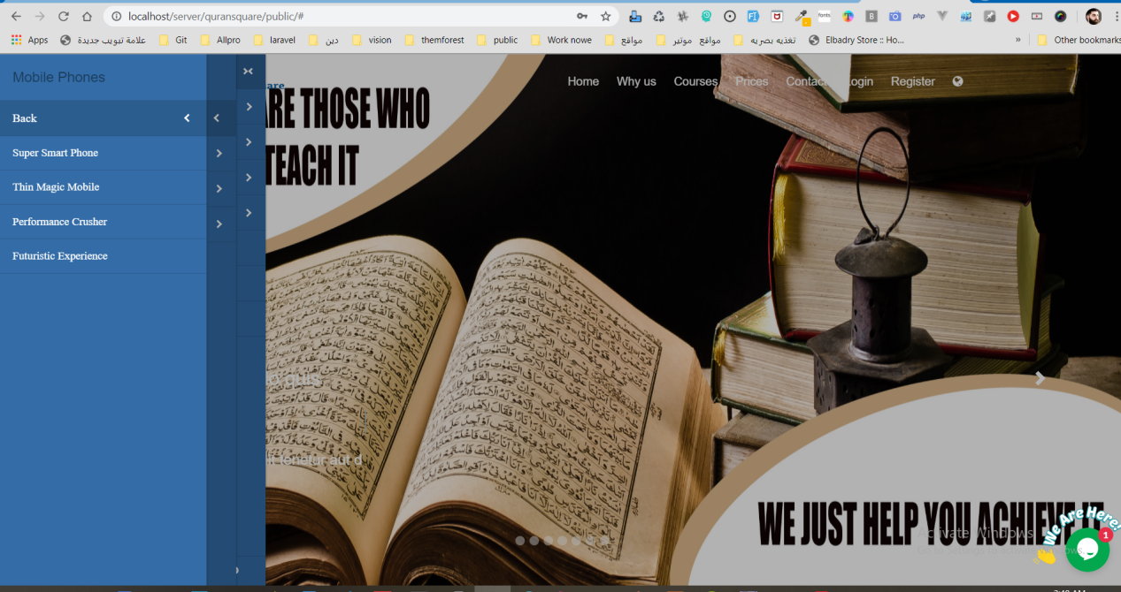

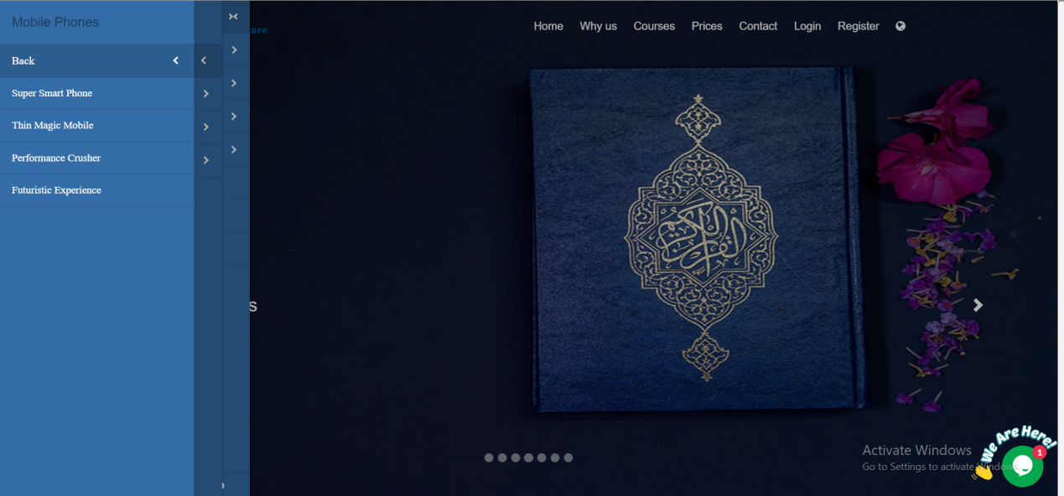

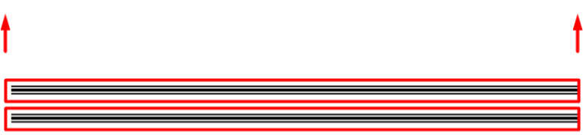



….……………………………………………………………………………………………………………………………………………

عايزين بقا نركب ال اسليدر الحلو الجميل ده تعالى كده نشوف ازى مع بعض

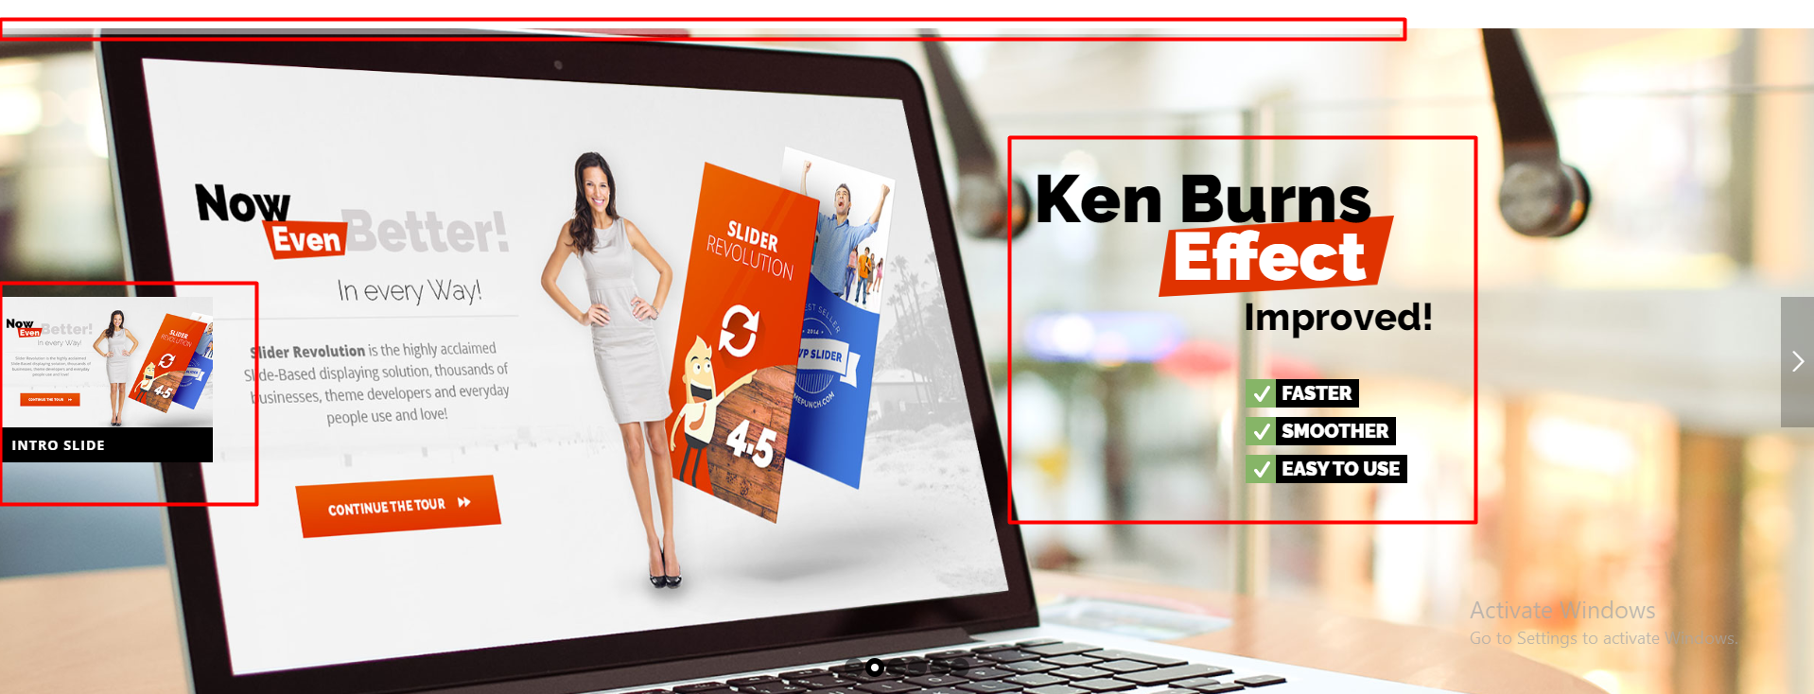……………………………………………………………………………………………………………………………………………..



تمام تعالى بقا نشوفو هو بيعتمد على اى

